How to Upload OTA Supporting Documents to your Application

After submitting your application, you will be directed to this screen:
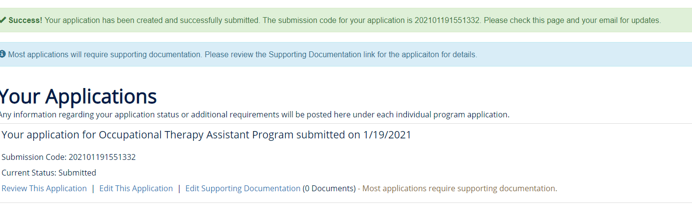

Click on the Edit Supporting Documentation link.
You will then be directed to this screen:
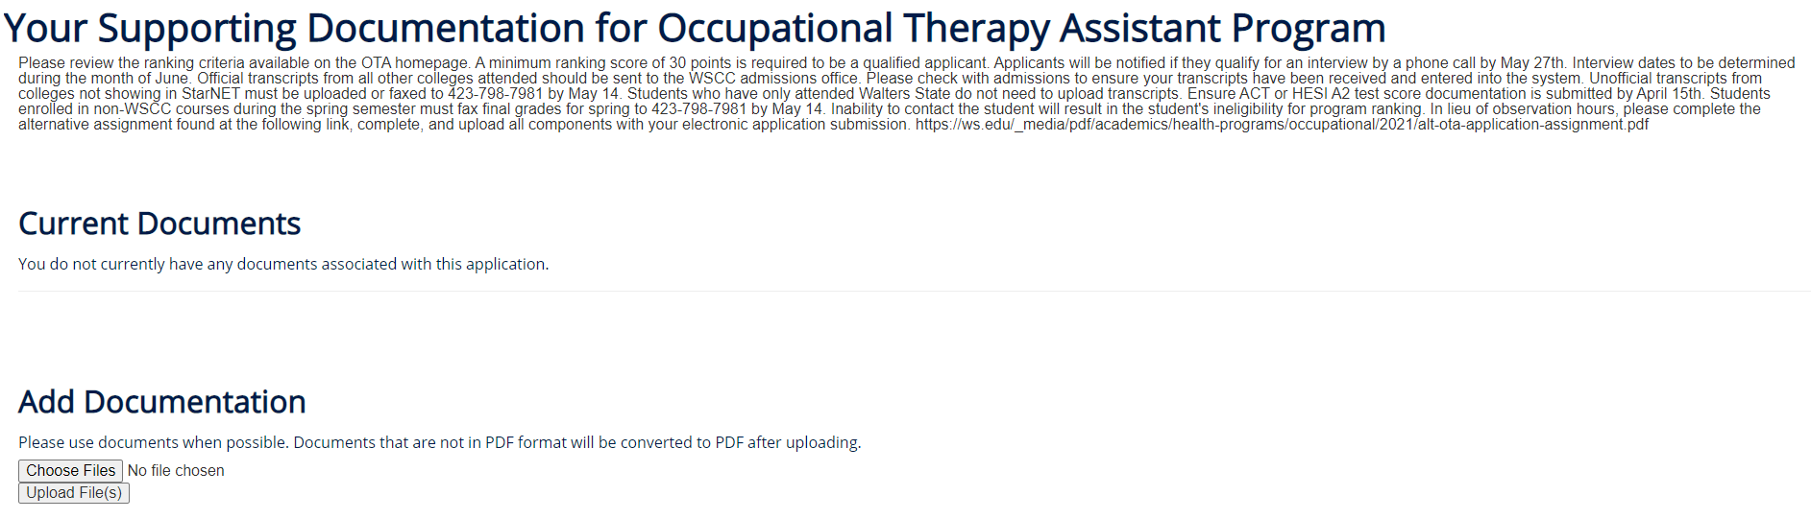

Click choose files. Name the files with your first and last name and the name of the document i.e. borencourtneyalternativeassigment.doc or borencourtneyletterofreference.doc
Click Upload Files

For Walters State Use Only
Document Number
WSCC 35569-13265 3/26

