How to Complete & Submit Electronic Forms
- Activate WS ID account at https://ws.edu/account/home/ActivateAccount

- Log into MyWS from www.ws.edu 
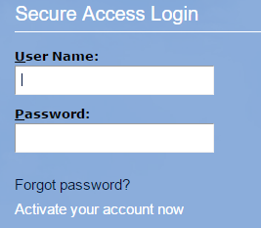
Activate account here
Password you have set
Example: jasmith
- Select an action item under “Student Alerts” or scroll down and choose “Aid Status” icon.
- If needed, choose appropriate aid year using the drop-down menu on top right.
- View Student Requirements.
- If FAO questions have not been answered, choose “View Questions” to answer
- All needed documents will appear – some documents will take you to an electronic form, please visit/call your nearest Financial Aid Office to retrieve other in-office forms or submit supporting documents required.
- Electronic forms can be accessed by selecting the form link of each required form
  - Once selected, the form link will take you to a Dynamic Forms login screen
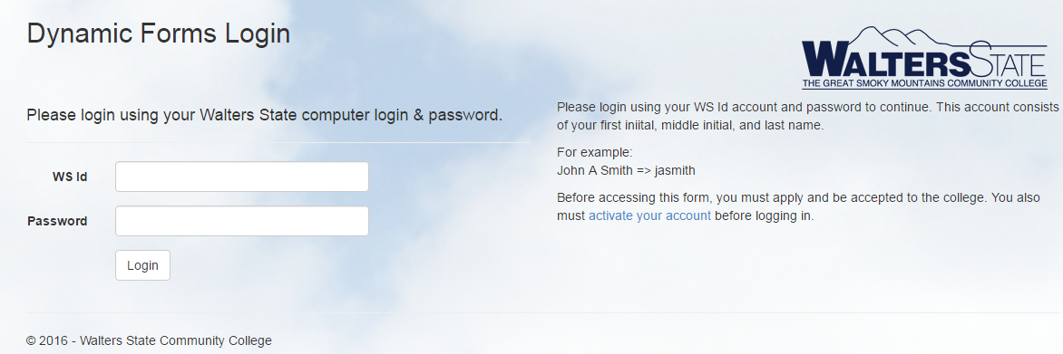
If you have password issues, please contact the Walters State Help Desk at 423-318-2742
Example - jasmith
- Upon successful login, the selected form will appear.

Independent Students
- Once form appears, student will complete the form.
- Upon completion of the form, student will electronically sign and submit. The form will be sent electronically to the Financial Aid Office for processing.

Dependent Students
- Once form appears, student will input parental information (parent who signed FAFSA)
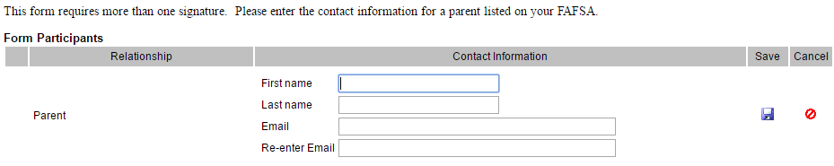
*Parent email must be different from student*
- After form is electronically signed and submitted by student, parent will receive an email to complete and electronically sign (parent will create their own Dynamic Forms account). (Parent should check Spam/Junk folders for email from Next Gen.)
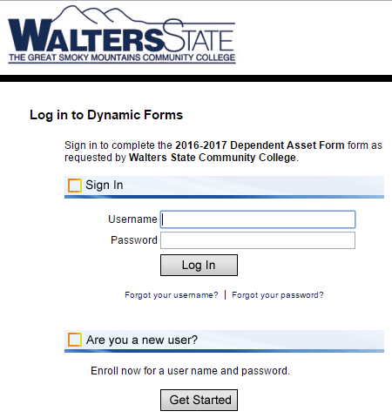
- Upon completion of the parent section (if applicable) and parental signature, the form will be sent electronically to be processed by the Financial Aid Office

Please monitor your MyWS account for additional requirements or updates

