How to Register via Find Classes Tab

- Log into your MyWS using your username and password. You may access your MyWS from the Walters State homepage (https://www.ws.edu) by clicking MyWS at the top of the page.

- Select “Register.”
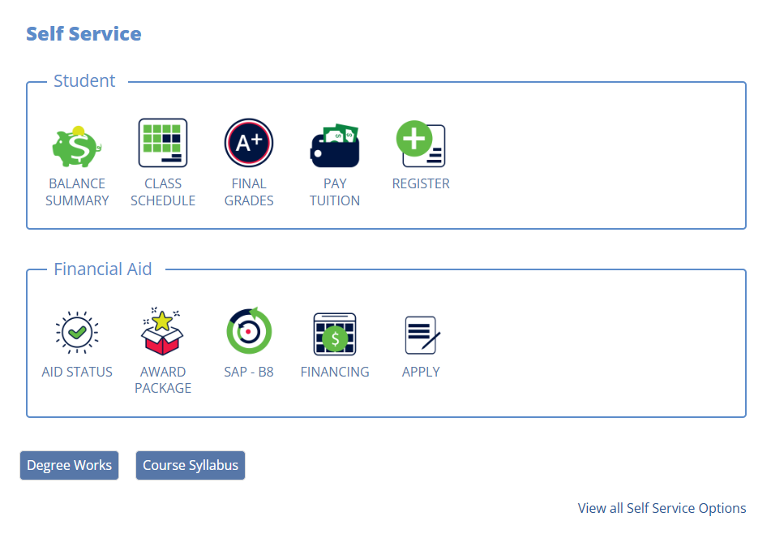

- Click the “Student” tab. Please note: the student tab will already be selected, but you need to click on it again to get the new menu options.
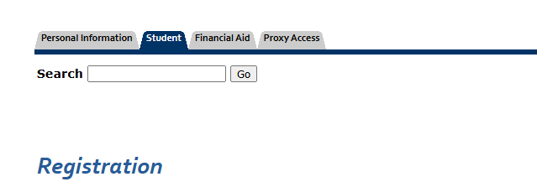

- Click “Registration (9x).”
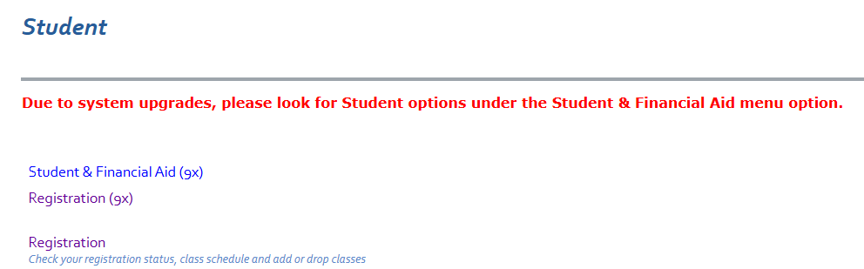

- Click “Register and Drop Classes.”
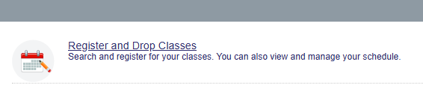

- Select the term you are registering for in the drop-down and click “continue.”
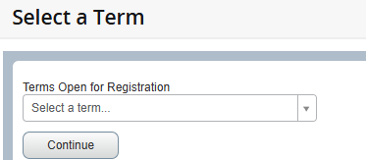

- Search for Classes using a basic or advanced search. For basic search, enter a subject and course number. For advanced, click the “advanced search” drop down and enter your search criteria. Click “Search” after you have entered your search criteria.
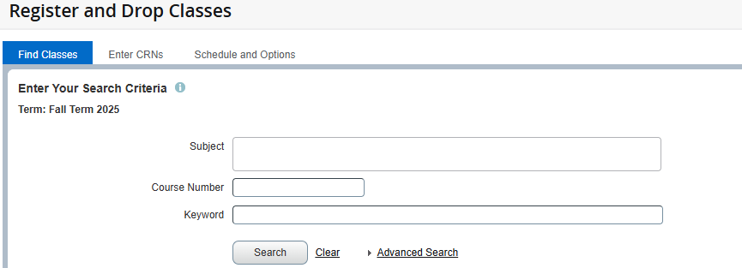
- Course options that meet your criteria will display on the next page. Once you have found a class you would like to add, click “Add” in the far-right column.
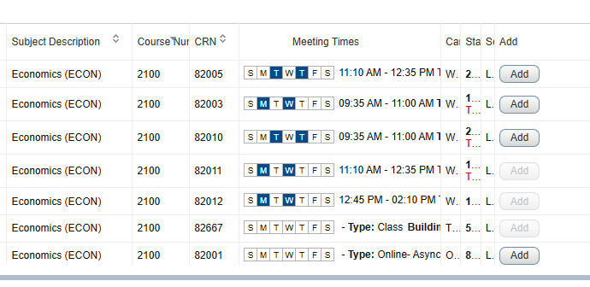

- You can revise your search criteria or look up a new class by clicking “Search Again.”
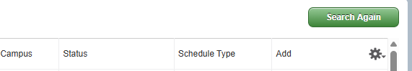

- Verify your course selections and schedule with the panels:
- The Summary panel will pop up at the bottom right.
Pending classes will say pending and be listed as gray. *Please Note: All previously processed registration changes including add or course drops will be in green.

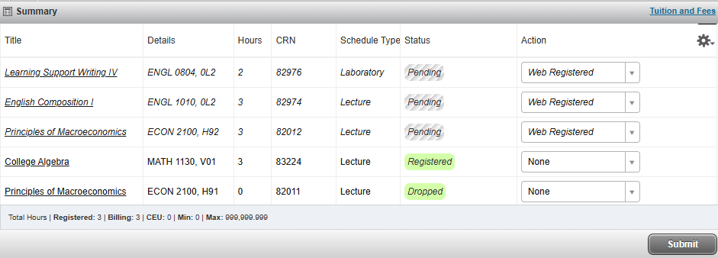

- The Schedule panel will pop up at the bottom left.
Pending classes will say pending and be listed as gray. *Please Note: All previously processed registration changes will be included. All courses you are currently registered for will be solid and have a green checkmark.
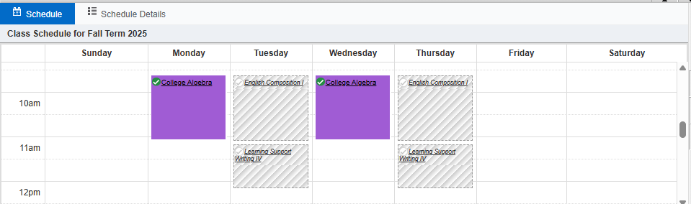

- Once you have verified the classes status and the schedule is correct, click “Submit.”

- Classes will say registered in green in the summary box and will turn solid with a green check mark in the schedule box. If there is an error adding the class, it will stop you from registering and give you an alert in the top right corner and the status column. If you have errors that you cannot resolve, please contact your advisor.

- To view and/or print your schedule, click on the “Schedule and Options” tab. To print, click the print icon.

