How to Register via Enter CRNs Tab

- Log into your MyWS using your username and password. You may access MyWS from the Walters State homepage (https://www.ws.edu) by clicking the MyWS icon at the top of the page.

- Select “Register.”
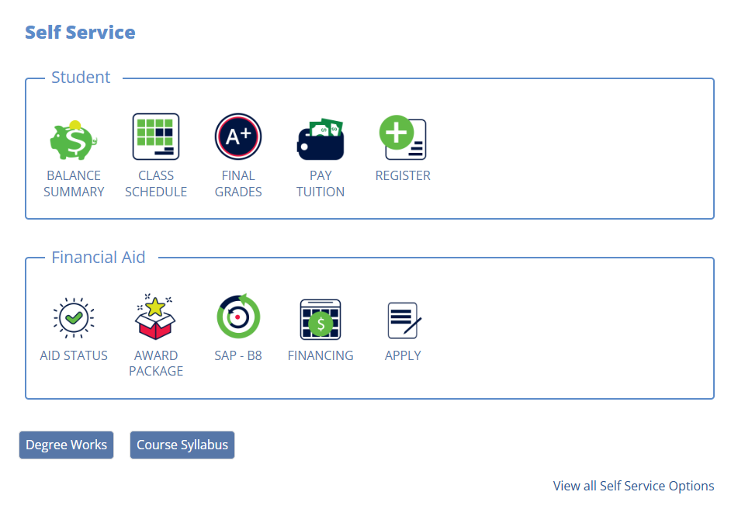

- Click “Student” tab. Please note: the student tab will already be selected, but you need to click on it again to get the new menu options.
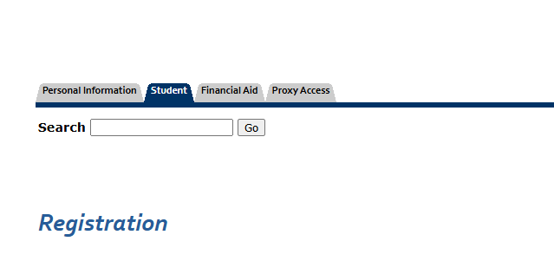

- Click “Registration (9x).”
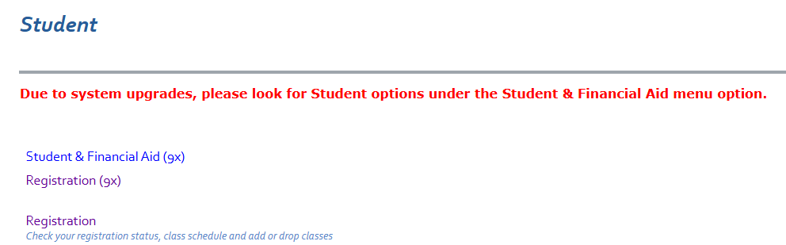

- Click “Register and Drop Classes.”
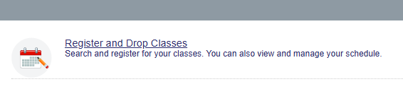
- Select the term you are registering for in the drop-down and click “continue.”
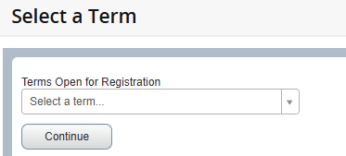

- On the next page, click the “Enter CRNs” tab.
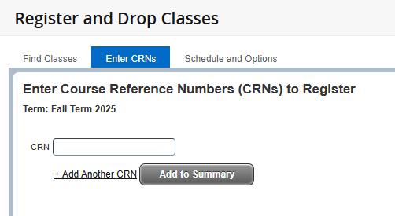

- Directly enter the classes five-digit CRN in the box under the “Enter CRNs” tab.

- Click “Add Another CRN” to input more CRNs. As you enter CRNs, it will list the class information for that CRN to the right.
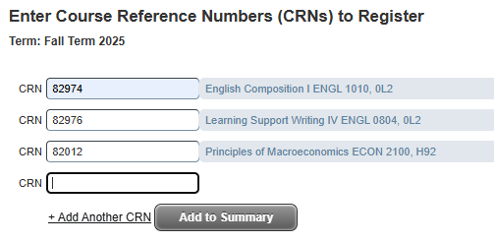

- Once you have entered all CRNs in the boxes, click “Add to Summary.”

- Verify your course selections and schedule with the panels:
- The Summary panel will pop up at the bottom right.
Pending classes will say pending and be listed as gray. *Please Note: All previously processed registration changes including add or course drops will be in green.

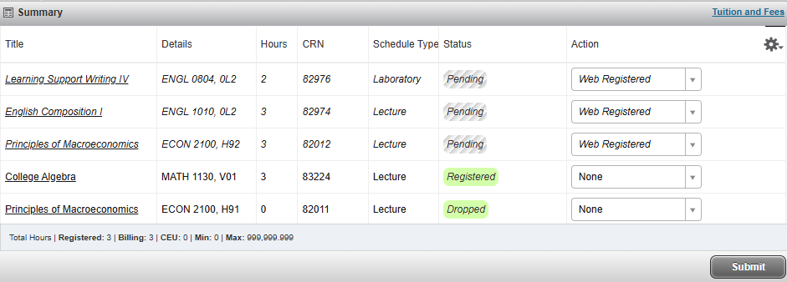

- The Schedule panel will pop up at the bottom left.
Pending classes will say pending and be listed as gray. *Please Note: All previously processed registration changes will be included. All courses you are currently registered for will be solid and have a green checkmark.

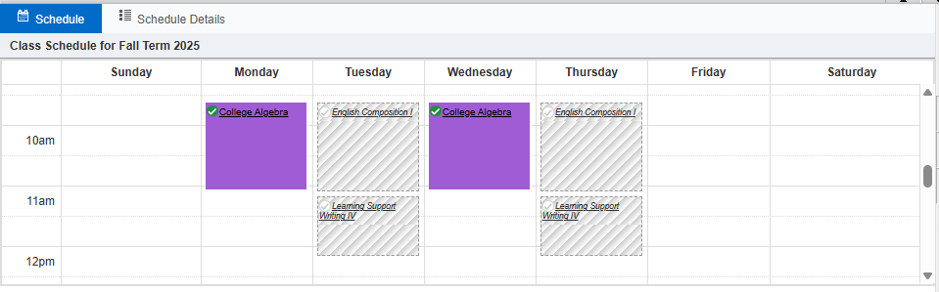

- Once you have verified the classes status and the schedule is correct, click “Submit.”
- Classes will say registered in green in the summary box and will turn solid with a green check mark in the schedule box. If there is an error adding the class, it will stop you from registering and give you an alert in the top right corner and the status column. If you have errors that you cannot resolve, please contact your advisor.
- To view and/or print your schedule, click on the “Schedule and Options” tab. To print, click the print icon.

