Financial Aid Quick Help Guide for MyWS

Financial Aid 101 for Logging into MyWS
- Go to Walters State homepage at www.ws.edu
- Click on MyWS  icon located on the top left side of the homepage
- Log into MyWS & Complete Multi-Factor Authentication
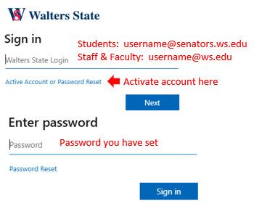
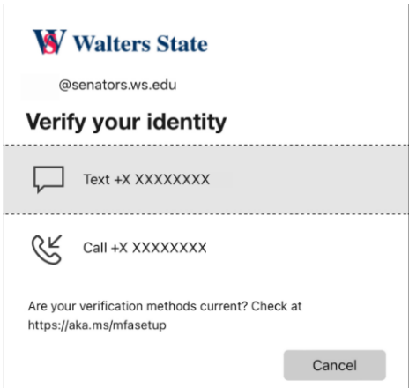
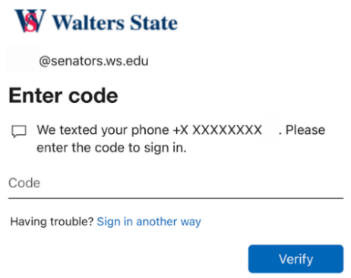

Financial Aid 101 for Completing Outstanding Student Requirements
- Log into MyWS
- Select an action item under “Student Alerts” or scroll down and choose “Aid Status” icon
- If needed, choose the appropriate aid year using the drop-down menu on top right
- View Student Requirements
- If FAO questions have not been answered, choose “View Questions” to answer

Financial Aid 101 for Viewing Lottery Scholarship Eligibility
- Log into MyWS
- Select “Aid Status” icon
- Select “Student Lottery Information” under the General Links section
- Choose appropriate term and click “Submit”

Financial Aid 101 for Viewing Financial Aid Award Information
- Log into MyWS
- Select “Aid Status” icon
- Change the appropriate aid year using the drop-down menu on top right
- Select “Offer” option at the top
- Select “Payment Schedule” to see when any Pell grants, supplemental grants, Lottery, TN Promise, or scholarships will be awarded

Financial Aid 101 for Viewing Financial Aid Applied to Tuition & Fees
- Log into MyWS
- Select “Balance Summary” icon
- Select “View by Term” in drop-down menu
- Choose the appropriate term

Financial Aid Information Available Through MyWS

Financial Aid

Financial Aid Home
- View student requirements (unsatisfied & satisfied), general financial aid links

Financial Aid Offer
- Review awards and other resources; Display award payment schedule; View Student Aid Index and Cost of Attendance information

Financial Aid History
- View awards and award amounts from past academic years

Resources
- View responses to Financial Aid Prior Year and Current Year Authorizations and Incarceration

Notifications
- View Messages from the Financial Aid Office to Student

Satisfactory Academic Progress
- Display academic progress history

College Financing Plan
- View College Financing Plan

Glossary of Financial Aid Terms
Verification – Verification is the confirmation through documentation that the information provided on a student's Free Application for Federal Student Aid (FAFSA) is correct. The federal government requires colleges and universities to verify or confirm the data reported by students and their parent(s) on the FAFSA.
Tax Return Transcript – Students selected for verification need to provide a tax return transcript to verify their income or their parents’ income. Tax return transcripts show most line items from your tax return (Form 1040) as it was originally filed, including any accompanying forms and schedules. This transcript does not reflect any changes you, your representative or the IRS made after you filed your return.
Student Aid Index – An eligibility index number that determines how much financial aid you would receive if you attend the school.
Authorization/Prior Year Authorization – The act of voluntarily authorizing Walters State Community College to apply your financial aid funds to pay charges other than tuition and fees, such as library fees, traffic fines, etc. for the current or prior academic year.
Incarceration – Incarceration is the state of being confined in prison; imprisonment

