

How to Schedule an Appointment with TracCloud

Step 1: Scan the QR code or click on the following link to go to your personalized dashboard:
TracCloud http://tutortrac.ws.edu/



Step 2: Click on the “Scheduling a Tutoring Appointment” box.

Step 3: Choose the Subject and Reason for the appointment and then click Search.

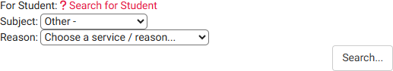
Your Name Will Be Here

Step 4: Choose an appointment from the list of available times, tutors, and campus locations.
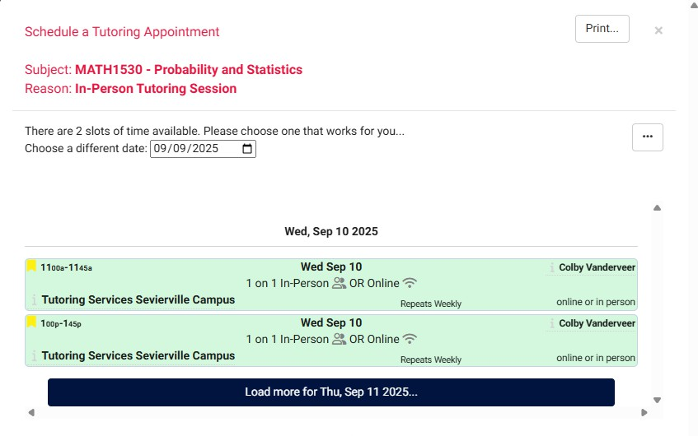
Tutor Name
Campus Name
Tutor Name
Campus Name

Step 5: Check the appointment date and time, the meeting type (In-Person or Online), and the campus location on the confirmation page and then click SAVE at the bottom left of the page.

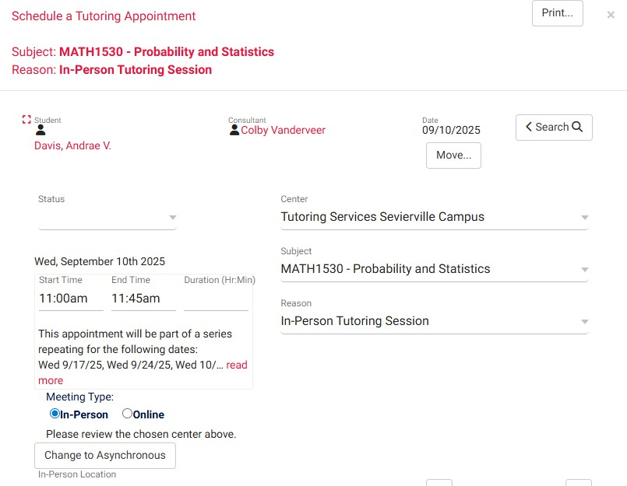
Your Name
Campus Name
Tutor Name



Revised 04/07/2026

